MySQL Lab-1

Question 1: Student Management System
Practice Tasks
- Create above table in database.
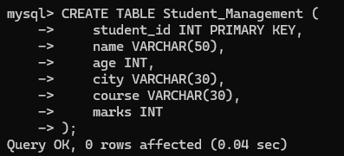
- Insert all 20 records.
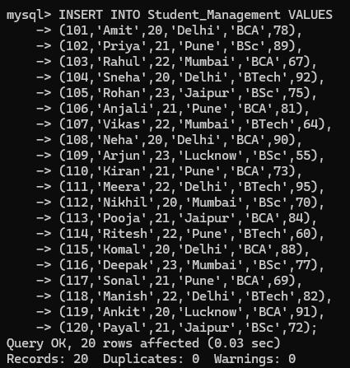

- Display all student records.
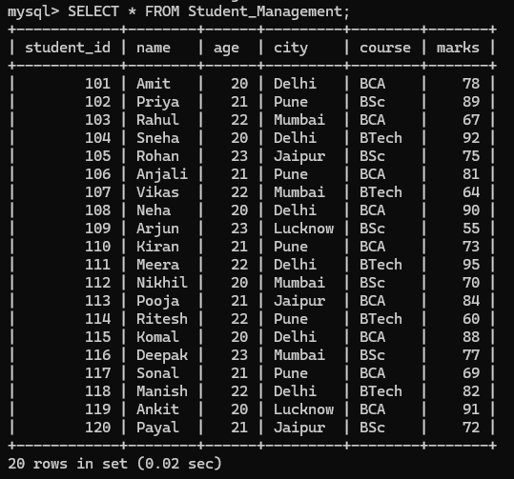
- Display only the names and marks of all students.
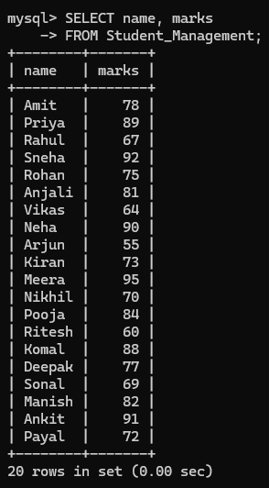
- Find students who belong to Delhi.
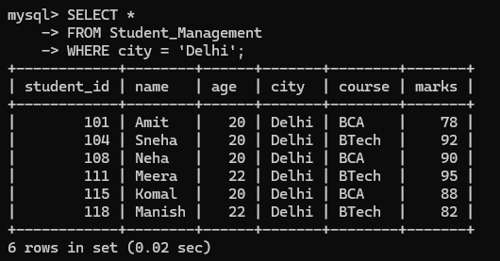
- Display students whose marks are greater than 80.
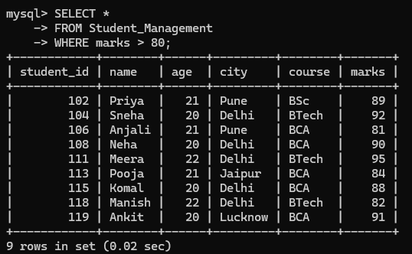
- Find all BCA students.
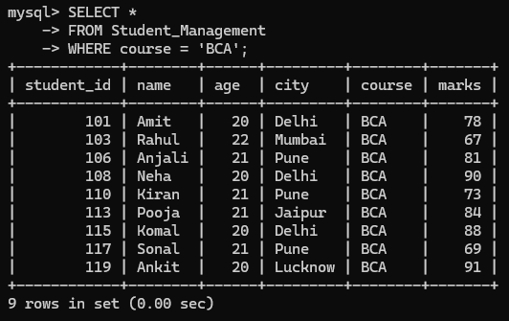
Question 2: Employee Database
Practice Tasks
- Create Above table in database.
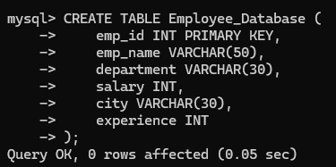
- Insert above 20 records.
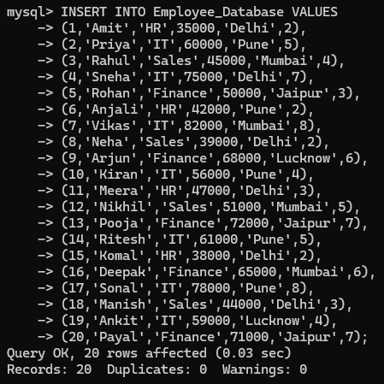
- Display all employee details.
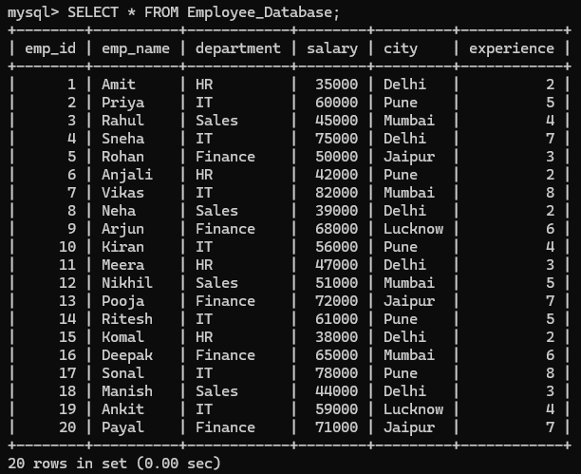
- Display employee names and salaries.
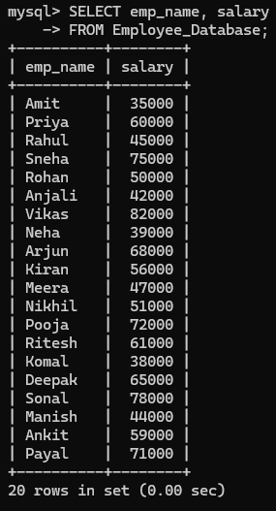
- Find employees working in the IT department.
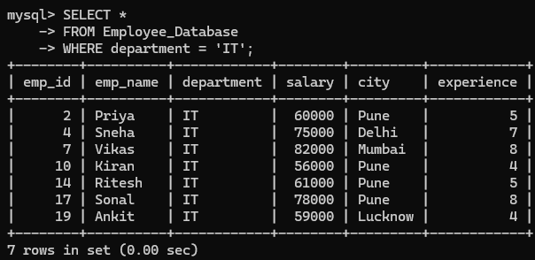
- Find employees whose salary is greater than ₹60,000.
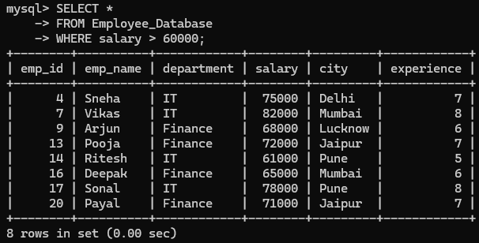
- Display employees having more than 5 years of experience.
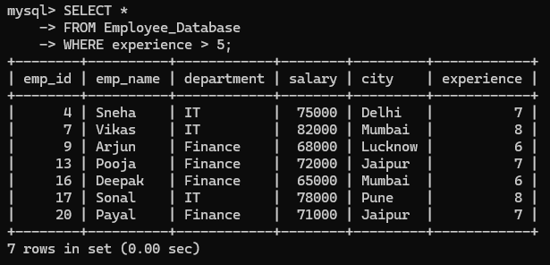

Question 3: Product Inventory
Practice Tasks
- Create above table.
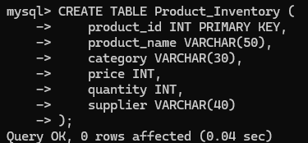
- Insert above 20 records.
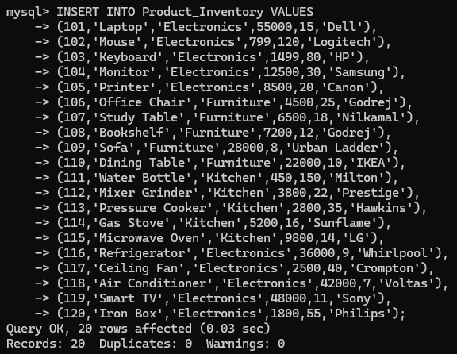
- Display all products.
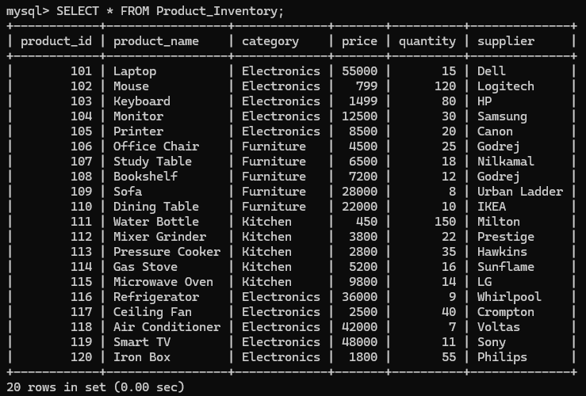
- Display only product names and prices.
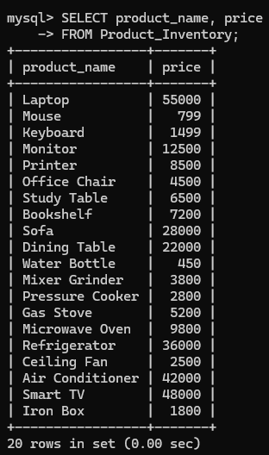
- Find all Electronics products.
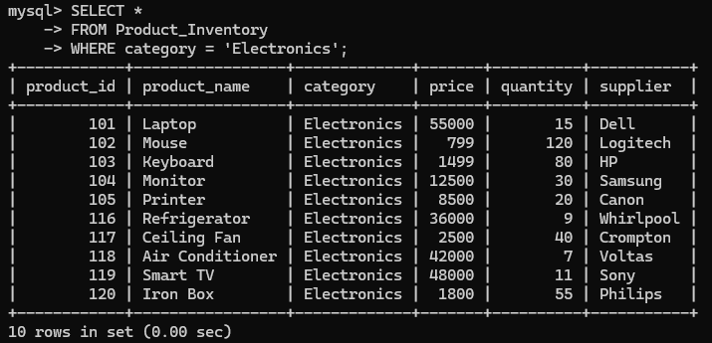
- Display products whose price is greater than ₹10,000.
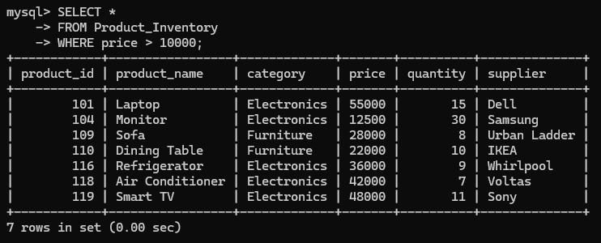
- Find products whose quantity is less than 20.
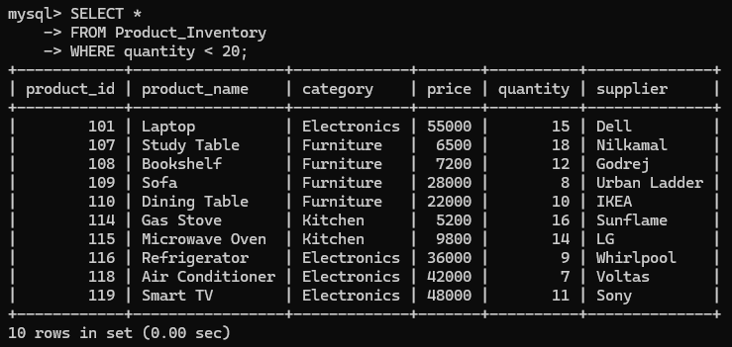

Question 4: Library Management
Practice Tasks
- Create above table.
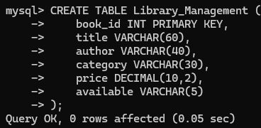
- Insert all 20 records.
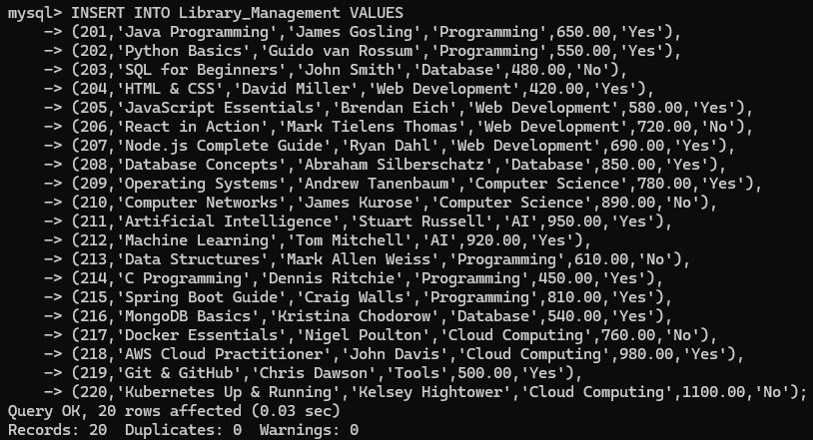
- Display all books.
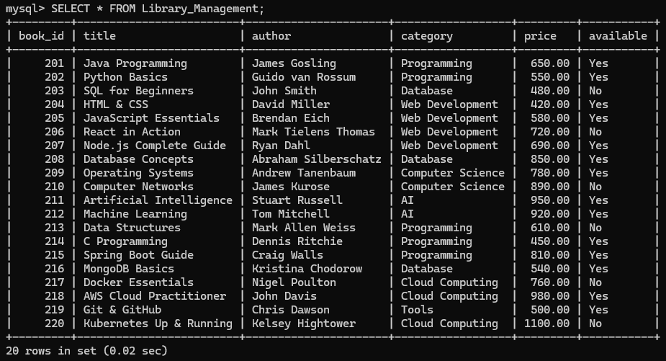
- Display only Title and Author.
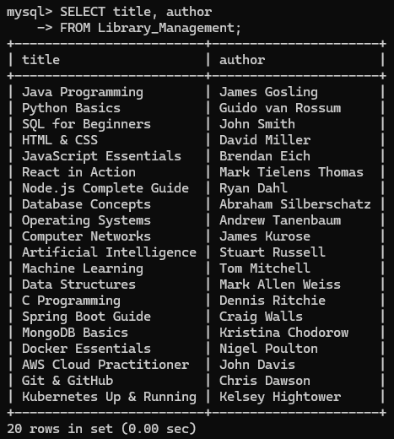
- Find all available books.
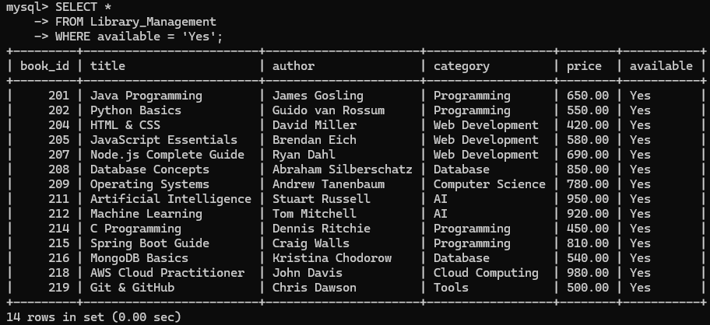
- Display books whose price is greater than ₹700.
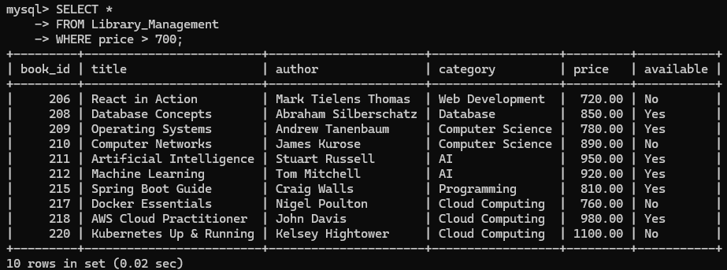
- Find all books in the Programming category.
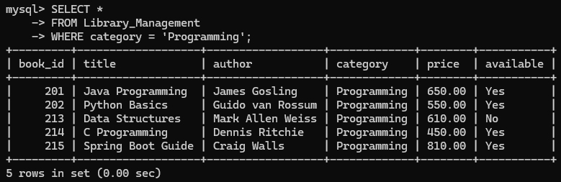

Question 5: Customer Orders
Practice Tasks
- Create above table.
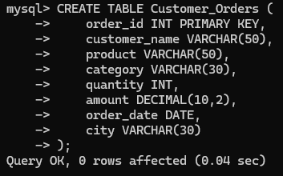
2. Insert all 20 records.
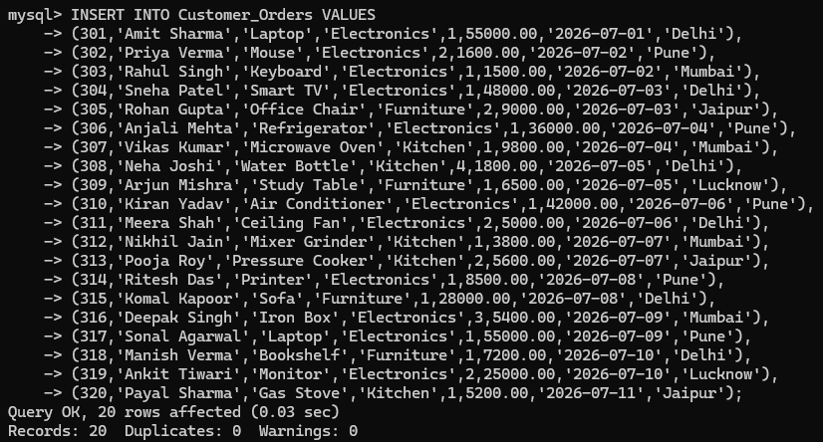
3. Display all orders.
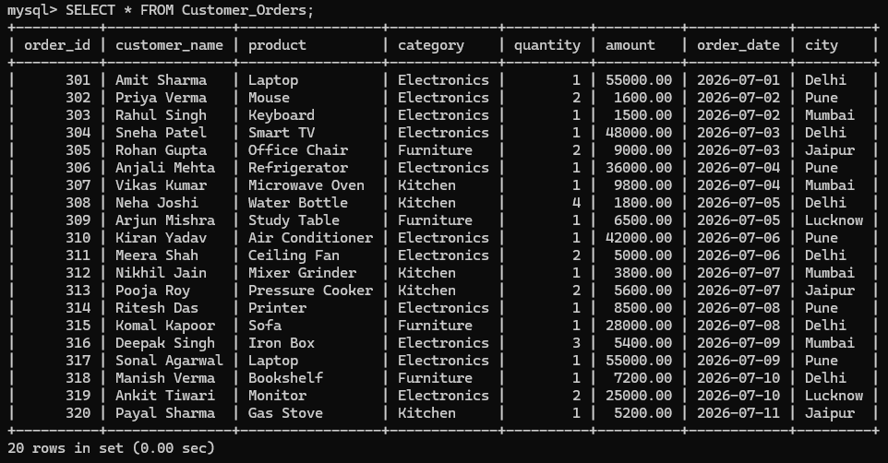
4. Display customer names and products.
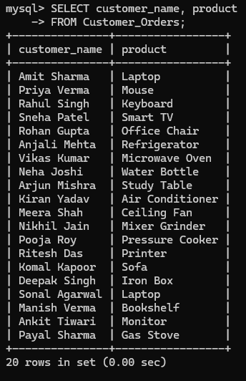
5. Find all orders placed from Pune.
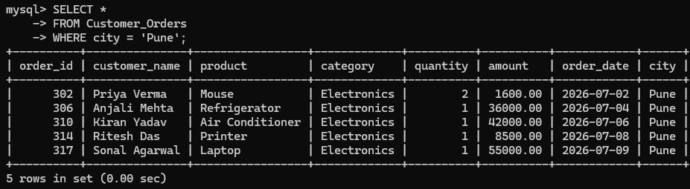
6. Display orders where the amount is greater than ₹20,000.
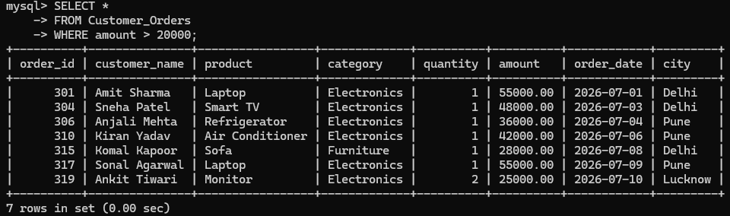
7. Find orders where the quantity is greater than 2.
